**LandPro Equipment Telephony Traffic Analysis Project Report**

**LandPro Project Team 1 – The Aces**

Mei Yin Fung

Xiaotian Jia

Di Jin

Wei Chen Lee

Hengjun Yang

Yuchen Yang

**Simon Business School | University of Rochester**

**Spring 2021**

Contents

Executive Summary3

Introduction4

Data Assumptions4

Label Definition4

**Missing Calls4**

**High Missing Rate4**

**Peak Season4**

**Cross/Target Calls5**

**Big Stores/Small Stores5**

**Regular Phone Line5**

**Additional Information5**

Data Cleaning5

Data Frame 16

Data Frame 26

Visualization and Insights6

Approach 17

Approach 213

Solutions and Recommendations22

Call Center22

Shifts Rescheduling22

Staff Deployment – Department/Region22

Training Staff on Answering Overall Questions23

## Executive Summary

Our client, LandPro Equipment, is a Dealership company that operates in the state of New York, Pennsylvania and Ohio. LandPro reached out to the team for a current business issue they identified within their daily operation and looking for solutions to optimize the process. The main issue the client identified is regarding the call volume within its peak season, in detail, the relatively high call volume in the peak season has caused high missing call rates that the client saw as an issue and believe there is space to improve. Furthermore, after installing a brand-new telephony system to the companies branch at all locations, the client has aggregated a huge amount of detailed call data that can be further analyzed for in-depth business insights. However, these data haven’t ever been analyzed for any purposes and this is a fresh zone to be discovered.

Both parties agreed that analysis on these data may lead the project to another level and potentially come up with solutions to solve the business issue. Our team, the Aces at Simon Business School University of Rochester, accepted this project and designed this analytical project from multiple perspectives including business issue clarifications, data cleaning, data analysis, visualizations, and solution generation.

## Introduction

**Data Assumptions**

Since the original data was generated with complicated rules, different dimensions worked together to express all details. To make the data cleaning efficient and accurate, we analyzed similar cases, made our deductions and got them tested and confirmed with our client. These are the assumptions we made for the further steps (All details were included in the code file we attached):

1. Consider rows with the same tracking ID as one call, ordering them by the local ID would assign the timeline to it.
2. Consider rows with the same tracking ID as one call, normally, there would be at least one of them were answered. Because normally they would be connected to the Main Line at first and then the target departments are chosen.
3. Consider rows with the same tracking ID as one call, after assigning the order, if the First Name and Last Name boxes of the last row were filled as “Voice Portal”, this call was transferred to leave a voice message, and no one answered it afterwards.
4. Consider rows with the same tracking ID as one call, after assigning the order, for the first row of data, if the department box was not empty and the direction of this call is outbound, this represents that the call is inter-company. Otherwise, it’s a call from outside.

**Label Definition**

Since the system is new, our client doesn’t have a hard standard for every detail of the data. To provide the best analysis and explanation, we defined the methods shown below ourselves.

**Missing Calls:** (As long as the call fits any one of them below)

* Consider inbound call only, consider tracking ID as one single call, if answered amount is smaller than two but the number of records is larger than one, it’s a missing call.
* If there are departments in the record, then if the sum of “answered” of all departments does NOT equal to zero, the call is answered. If there’s no department record, then if the sum is zero, the call is missed.
* If the call ended at “Voice Portal”, it will be labeled as “Missing call”.

**High Missing Rate:**

* By averaging from the missing rate from Feb 2020 to Jan 2021, we define significantly high missing rate as 5.82%
* The client does not have standard of defining high missing call rate so 5.82% is not a strict standard to justify whether a region has high missing call rate or not.

**Peak Season:**

* We chose to use the months with highest phone call volume instead of those with highest missing call rate. High missing rate is not able to logically define a peak season, since missing too many calls would have many factors, like shortage of employees, low work efficiency, etc.
* Therefore, we define peak season includes April, May, and June as they have the highest phone call volume.

**Cross/Target Call:**

* Cross represents calls that go to multiple departments. Target represents calls that go to one department by customer.

**Big store/Small store:**

* Using client provided extra employee data, we filtered out any employee with “company” as branch description and “technician” or driver” as position.
* By using the median as the threshold to separate these 20 stores as small or big, we defined those stores with more than 15 employees are big stores, and the ones with less or equal to 15 employees are small stores.
* Big stores are Falconer, Hall, Avon, Brockport, Alexander, Oakfield, Halifax, Watsontown, Stoneboro, and Springville.
* Small stores are Clymer, Savannah, Macedon, Fairmount City, Niagara Falls, Edinboro, East Palestine, Harrisburg, Centre Hall, and Mifflintown (size of store is in a descending order).

**Regular phone line:**

* Regular phone line was identified as average answer call is higher than 5 per month for each people or phone line depends on store structure.

**Additional Information**

* Since the different finished time of system installation among regions, not all regions’ data were collected during the whole period, which is why some regions have less than eighteen months’ data, but some of them have more. To avoid the bias this may bring, when the analysis is about the time series, we only included the months with data of all regions which is between Feb 2020 to Jan 2021.
* Client focused on Sales, Service, Parts, and Admin departments performance when considering about pick-up rate in company.
* Although one way of dealing with the peak seasons was hiring short-term employees, our client prefers not to keep using this strategy.
* No specific standard to define the range of high missing rate.
* Extra employee data that containing number of employees, belonged departments, and regions is provided by the client for a better integrated analysis.

## Data Cleaning

In this step, we made assumptions as we mentioned above and finalized two data frames as outcomes, which contain data of different perspectives. We accomplished this by making functions in R, the codes is attached with this report.

During the cleaning process, we found that not all the calls were made by customers to our client. The fact is that there were many calls made between different stores and departments of our client. In this case, cleaning and summarizing the dataset from different perspectives is essential. Eventually, we chose the customers’ perspective and company’s perspective.

One detail which was in common of both datasets was, we separated time into different columns and kept the smallest unit as hour. Because in our vision, for this analysis, focusing on every minute was unnecessary, hour wise was good enough as a time unit to show details.

Details are shown below:

**Data Frame 1:**

***Sample Data Frame 1***

We created this dataset based on customers’ perspective. In their thoughts, compared with other aspects like departments or regions, either or not their calls were answered should be the most important target. In our vision, this dataset can reflect this aspect the most.

Compared with the original data, this dataset summarized every call as one signal row. Instead of showing all details, we chose to focus on if one call was missed as a whole piece. For columns, we included tracking ID, details about time, region, department, and if it’s missed.

**Data Frame 2:**

***Sample Data Frame 2***

We created this dataset based on company’s perspective. From the company standpoint, every call should be considered since it took the system’s capacity, no matter it happened outside or inside the company. Besides this, the time, location, department and if it’s internal were all needed to be considered. That’s the reason why we added them as new columns compared with the previous table. In our vision, this dataset should be able to reflect all these aspects.

Compared with the original data, this dataset summarized every call by their tracking ID, locations and department where they happened, which is also why some of the tracking IDs were repeated for several rows. Instead of keep missing as the standard, in this dataset, to get a better vision of departments, we used a label “Answered” as the binary variable for every call in every department it’s related to. Because some calls would be rung in many departments, but only one of them would answer this if it’s answered, this variable would be helpful when we analyzed departments’ capacity and call volumes.

## Visualizations and Insights

For this section, we conducted the research from two different approaches and they each contain insights of different level and various heterogeneity. These two approaches provided us with multiple angles to locate where the issues are and helped us to come up with the final solutions in the next section.

Approach 1

The first overall approach is a series of logical continuously analysis. We started this process from analyzing the monthly total call volume from February 2020 to January 2021[1] to identify the exact period of peak season as the client believed the peak season to be a period that has to be concentrated on. After this identification, we then used missing call label from the datasets created above to compute the missing call rate for each individual month. This allows us to intuitively compare the condition within this peak season period to the rest of the months and reassure that the peak season is correctly identified to be analyzed more in-depth. Our next step from here is to do a by region/branches analysis to take a look at the performance of each branch in different months and weekday/weekend settings, which we strongly believe that this will provide us with more than enough information for a few detailed final solutions that are crafted uniquely for the stores with the biggest problems.

* **Monthly Call Volume:**

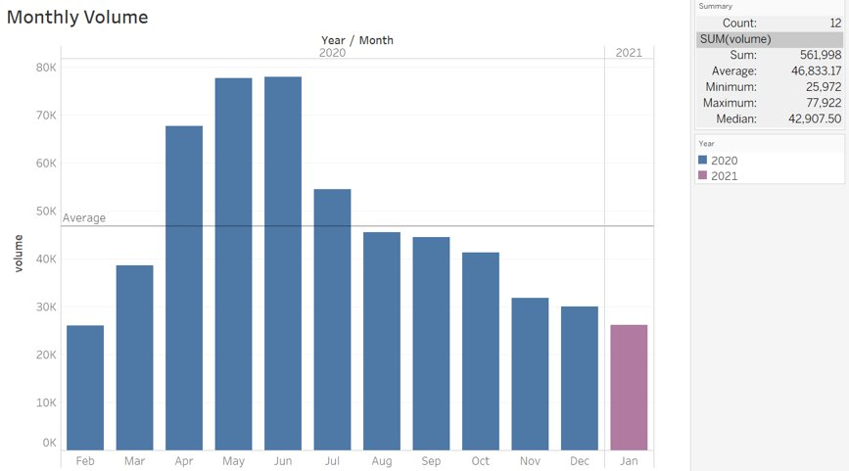

***Figure 1. Monthly Call Volume***

By calculating the monthly call volume of all the 20 stores, we found that April, May and June had higher call volume compared with other months. Therefore, we defined these three months as peak season. The highest call volume of the entire year was June, which had almost 78,000 calls within a month. In average, call volume is around 47,000 calls in a year (used the year of 2020 as a reference).

* **Monthly Missing Call Rate:**

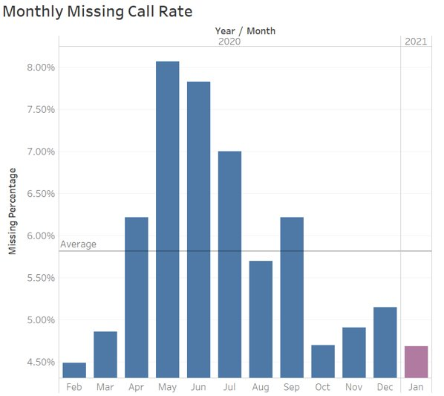To find out the monthly missing call rate, we divided total missing calls in each month by the total call volume in each month that shown in figure 1. We found that the peak season of missing call rate is similar with the peak season of total call volume that shown in figure 1. Therefore, we defined the peak season of missing call rate is also from April to June. The highest missing call rate was in May, which was 8.07%. While the average missing call rate was 5.82%.

***Figure 2: Monthly Missing Call Rate***

* **Missing Call Rate by Region:**

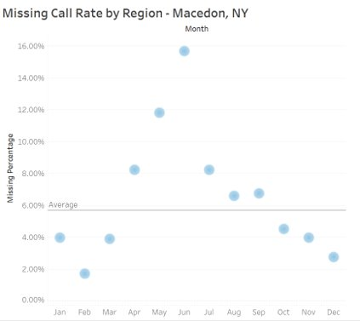

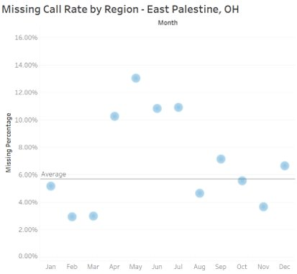

* 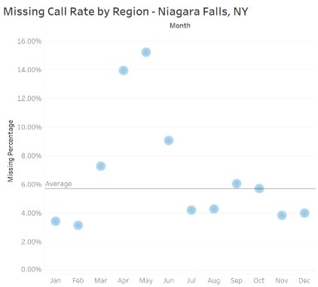

***Figure 3a, 3b, 3c: Missing Call Rate in Macedon, NY; East Palestine, OH; Niagara Falls, NY***

By inspecting missing call rate in all 20 stores, we found that Macedon, NY; East Palestine, OH and Niagara Falls, NY have the highest missing call rate in the peak season. Their highest missing call rates were 15.7% (Figure 3a), 15.2% (Figure 3b) and 13.03% (Figure 3c) respectively. The average missing call rate of these three cities were around 6%.

* **Missing Call Rate by Weekdays & Weekend:**

We defined that peak season include April, May, and June based on the fact that they have the highest phone call volume around the year for each region. To define the significantly high missing rate, we framed a standard of 5.82% that averaged the missing call rate from Feb 2020 to Jan 2021. By visualizing the Missing Call Rate vs. Total Call Volume for each region during the peak season (Figure 4) in a descending order of total call, we found out some stores received high call volume but attained low missing call rate, which means they are able to handle those customer phone call traffics, e.g. Brockport, Watsontown, Avon. The store in Avon, the highest phone call volume receiver during the peak season, has rather low missing rate, which is 6.04%. Although this number is slightly higher than our defined standard of high missing rate (5.82%), we still categorized Avon store as that type of store that can handle phone call traffics well. On the other hand, those stores with rather lower call volume but high missing call rate would need deeper analysis to figure out the potential reasons and solutions for such problem. For instance, Harrisburg, Niagara Falls, East Palestine.

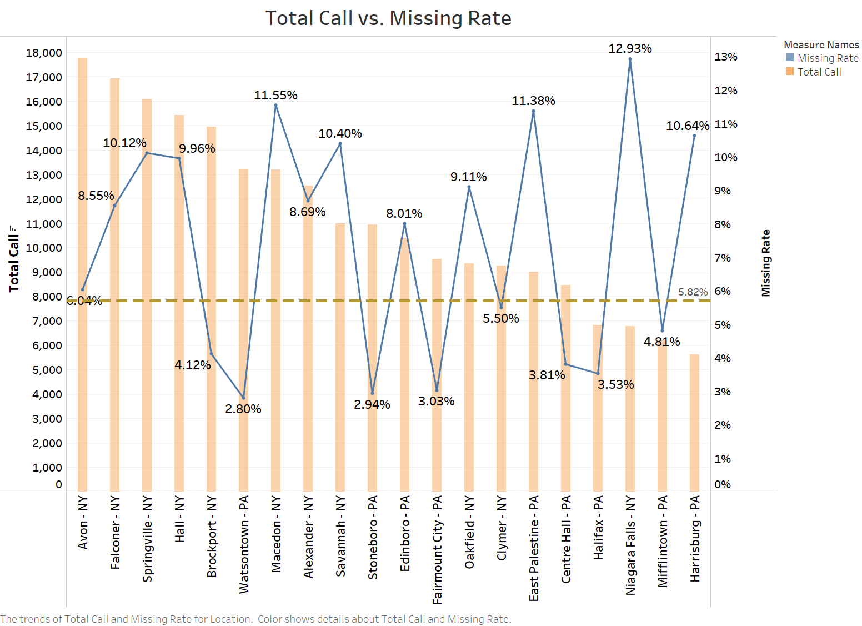

***Figure 4. Missing Call vs. Total Call Volume During Peak Season***

To find out the effective solutions from these observations from data visualization, we explored the correlation between weekdays and weekends for different region during the peak season. From the high-lightened regions in Figure 5, we observed these regions have a big gap of missing rate between weekdays and weekends. 30.79% missing rate of Harrisburg stands out of all of these locations, Niagara Fall, Savannah and Avon also had significantly high missing rate during weekend. Some regions like Macedon’s weekday missing rates are significantly high, to strived for more observations and findings, we analyzed different regions down to a level to inspect which day had the highest call volume in weekday.

***Figure 5. Weekday vs. Weekend for each Region During Peak Season***

* **Missing Call Rate by Weekdays & Region**

***APRIL***

***Figure 6a, 6b, 6c: Top Missing Call Rate by Weekday in April for 3 Regions***

We identified the branches in **Niagara Falls, NY/East Palestine, OH/Edinboro, PA** as the three branches that have the highest missing rates in April. The average missing call rate across all branches is **6.12%** and the top five rates are contributed by these three branches. Niagara Falls branch has the highest missing call rate on Tuesday and Monday even given the relatively low call volume; East Palestine branch’s problem is on Monday with the highest call volume among other weekdays; Edinboro branch suffers on Thursday and Friday given the lowest call volume throughout the week.

***MAY***

­­ ***Figure 7a, 7b, 7c: Top Missing Call Rates by Weekday in May for 3 Regions***

We identified the branches in **Niagara Falls, NY/East Palestine, OH/Harrisburg, PA** as the three branches that have the highest missing rates in May. The average missing call rate across all branches is **7.86%** and the top three rates are contributed by these three branches. Niagara Falls branch stand out with the highest missing call rate among the entire peak season[2] on Monday in May approximately three times higher than the average, given the lowest call volume throughout the weekdays; East Palestine branch has the second highest rate among the entire peak season on Monday as well, same as its issue in April, even with the lowest call volume among all weekdays; Harrisburg branch’s missing call rate on Monday needs to be concerned comparing to its low regular rate on other weekdays.

***JUNE***

***Figure 8a, 8b, 8c: Top Missing Call Rates by Weekday in April for 3 Regions***

We identified the branches in **Springville, NY/Oakfield, NY/Macedon, NY** as the three branches that have the highest missing rates in May. The average missing call rate across all branches is **7.34%** and the top five rates are contributed by these three branches. Springville branch is one of the branches that received the most phone calls and we believe these high rates on Monday and Friday are highly related to its call volume; Oakfield branch on Friday has low call volume but a relatively high missing call rate; Macedon branch’s performance in this month is something that has to be concerned, with its rates on each weekday are almost doubled the average rate, given the fact it’s not a store that receives large numbers of phone calls.

***Key Findings:***

Niagara Falls, NY/ East Palestine, OH / Macedon, NY / Harrisburg, PA are the stores that have to be optimize with special strategy/solutions. The solution for the rest of the stores will be altered based on different days of the week.

**\*We will discuss the strategy and solution based on the findings above in the solution section at the end of this report.**

Approach 2*[3]*

The second overall approach we created is strategically different from the first approach. In this step, we changed our priority to the difference among calls of departments with consideration of regions. We analyzed multiple aspects of different call types, the goal was to show the trends of these aspects of departments and locating the problems to specific regions.

**Internal/External Call Volumes During Peak Seasons:**

The first step of Approach 2 was classifying data by two conditions, where these calls happened, and which department took them. We considered calls into two categories, internal and external calls, dependent on whether they were made from inside the company or outside the company. Based on this idea, we classified them into departments of regions (In this step, we considered the four departments which client stated as the most important). Instead of only calculating the total volumes, we also considered whether the calls were answered generally or answered by specific department.

This graph is a sample based on our method and it contains the information of the store in region Alexander.

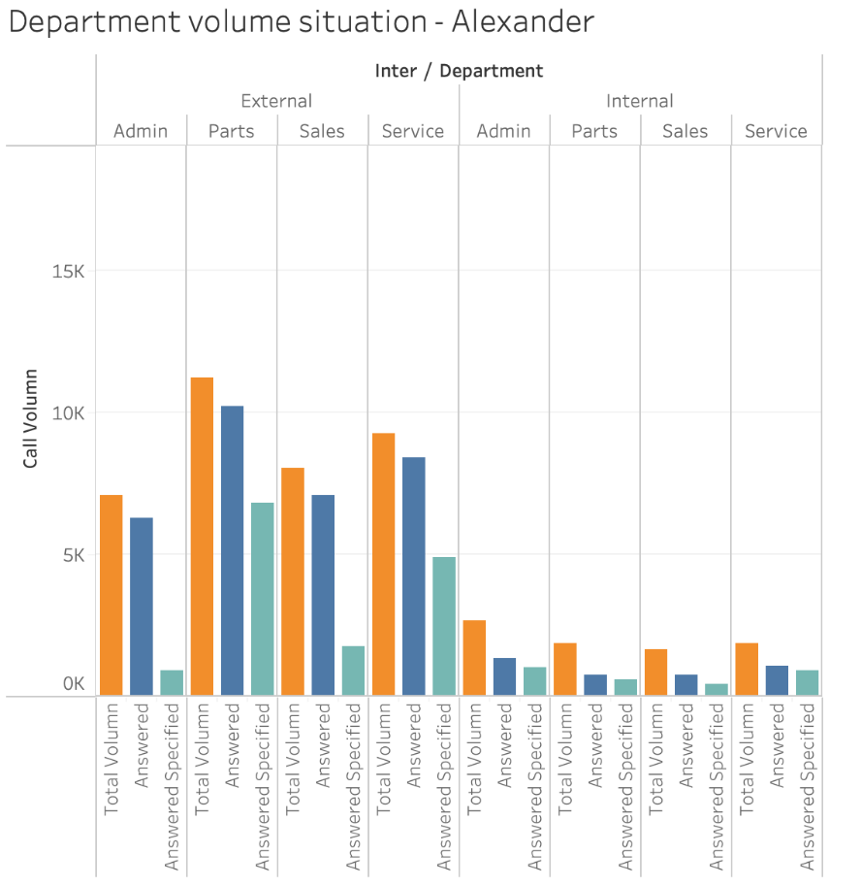

***Figure 9. Sample Call Volume by Department and Type***

Orange column mean total call volume, blue column mean whether this call is answered in this transaction, if it does, any department that happened in the transaction could be consider answered. And the green column means how many times this specific department answered the call.

The goal of this step was locating the most popular departments and stores. The answers for them were:

* In most stores, department Admin has the smallest call volume, while department Parts has the largest.
* Stores in Avon, Falconer, Hall and Springville are most popular.
* For Niagara Falls, all department's call volumes are equal

**Calls’ Answer Rate and Ending Rate:**

This step is the extension of two aspects based on previous step. Since we also considered whether the calls were answered or answered specifically, we would compare their weights in volumes and analyze departments of stores’ efficiency and professional ability. Call ending rate could represent their problem-solving abilities based on our understanding that call’s answer rate could represent the departments’ capacities and efficiencies.

These two graphs represent our method here, they contain the information from the store in region Alexander as well.

|  |  |
| --- | --- |
|  |  |
| ***Figure 10.a Sample Answered Call Percentage*** | ***Figure 10.b Sample Answered Specified/Answered*** |

The key findings and conclusions we had in this step are:

* In most stores, department Parts has the largest answer call rate although we have learned it also has the largest volume.
* In most stores, oppositely, department Admin has the smallest answer call rate although we have learned it has the smallest volume as well.
* Similar with departments’ trend, the store in region Avon has the largest call volume and highest answer rate in the meantime.
* Across all stores, most cases department Admin has relatively low capacity answering its own call while department Parts has it higher.

**Internal/External Cross/Target Calls:  
Part 1: Volumes**

In this step, our goal was assorting Internal and External calls into Cross calls and Target calls categories, so that we would be able to see the structure of Cross/Target calls and their volume at the same time.

**Part 2: Answer Rates**

In this graph, we summarized and visualized these groups’ answer rates as another angle.

|  |  |
| --- | --- |
|  |  |
| ***Figure 11.a Cross vs Target Volume*** | ***Figure 11.b Overall Pick Up Rate*** |

Key findings and conclusions:

* External calls have larger volume in both separated groups.
* Most Internal calls are Target calls, which makes sense since employees would know which departments they should call to solve different problems.
* Most Cross calls are External call, which makes sense since customers would be transferred to a random available customer service if their calls were picked up in the first place.
* Consumers' external calls’ answer rate is higher than internal calls’.
* When consumers call to specific departments, answer rates are higher.

**Call Volume by Number of Department Rang:**

The number of department rings in same call represents the different condition on call and may indicate the efficiency of store dealing with client issues. If the call only rang in one department, the client would have a clear target of the department he/she want to seek for help. Two may represent the call was answered firstly and then transfer to another department or the client find two department at the same time. Four may indicate the customer not sure which department to find or the initial rang was not picked up and thus the call was transferd and rang all department.

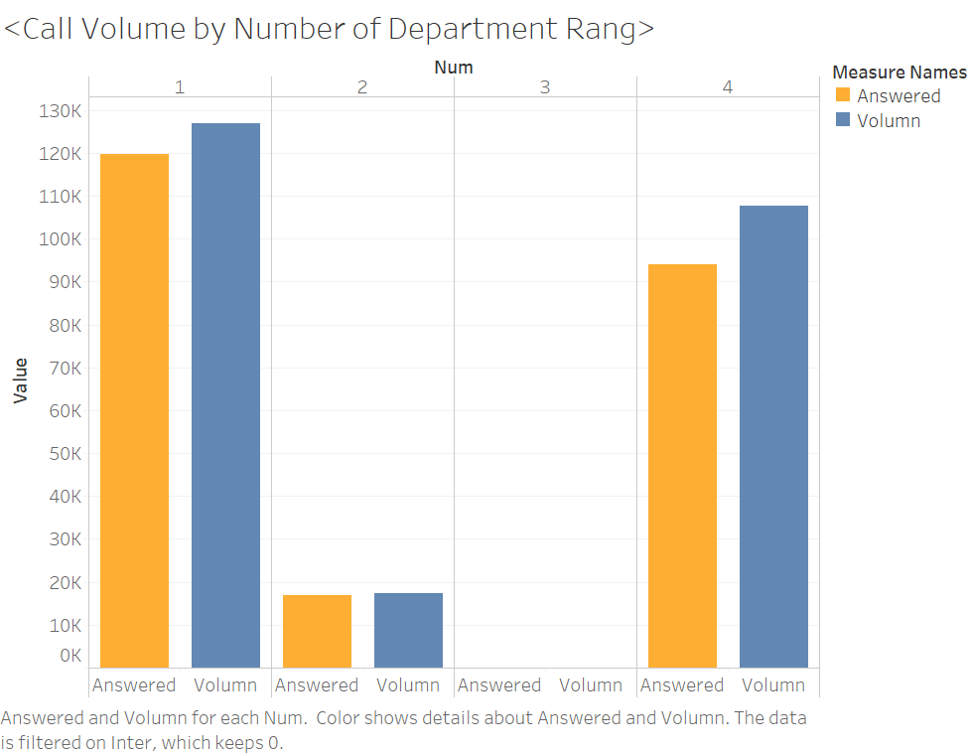

***Figure 12***

In Figure 12 we can see that cases with 1 and 4 departments have the highest chance to occur from customer call. Meanwhile, the missing call rate for 4 departments case is more than 10%, which is large than 1 and 2 department cases which were around 95%. This may result from the condition that the initial department miss the call and then rang all the department and none of them are able to be answered.

Meanwhile, we can separate stores by their ratio between target and cross call volume. If the target call is larger than cross call, then we’ll consider the store as target store and vice versa. The graph below shows the example of cross store and target store.

|  |  |
| --- | --- |
|  |  |
| ***Figure 13a: Cross Store*** | ***Figure 13b: Target Store*** |

|  |  |
| --- | --- |
| Cross Store: | Target Store: |
| Large Store | |
| Avon | **Brockpot** |
| Stoneboro | **Halifax** |
| Falconer | **Oakfield** |
| Hall | **Watsontown** |
| Small Store: | |
| Niagara Falls | **Centre Hall** |
| Savannah | **Clymer** |
| East Palestine | **Fairmount City** |
|  | **Harrisburg** |
|  | **Mifflintown** |

For Alexander, Edinboro/Macedon, and Springville, the different call types

Also, East Palestine, Harrisburg, Macedon would suffer missing call issues especially in 4 department categories. For these stores, they would tend to have more than 20% of missing calls while the call rang all 4 departments. These 4 stores were all categorized as small stores. Thus, this raises concerns about while in small stores, if one department cannot answer the call, there would probably be no other department to answer.

**Phone Line and Employee numbers**

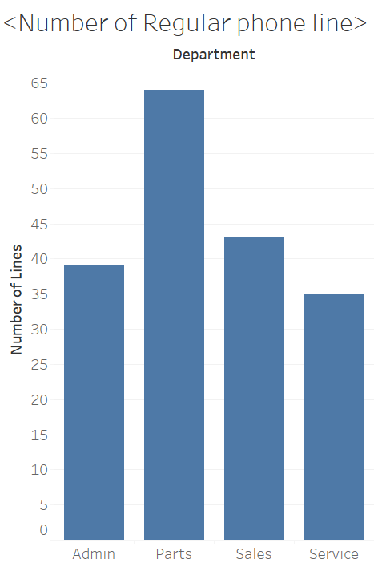A regular phone line was identified as the case where average answer call is higher than 5 per month for each staff or phone line depends on the store structure. Here we consider that the more the number of staff in the department who can regularly pick up the call, the higher the probability that the call would be answered.

The Parts department has the most regular cellphone lines and second-most employees, which allows the department to deal with the highest volume of calls and thus had a satisfactory answer rate during peak season. Comparatively, Service and Admin department may suffer from issues regarding their employee and phone line. For the Service department, it has the most employees, but the number of regular lines is far less (more than 50% less). Even we exclude employees who would not regularly present in the office(drivers), the large difference still raises our concern about the number of staff who can regularly pick up the call in the department. For the Admin department, the department also suffers a

***Figure 14***

similar situation. Compared to the missing rate by departments, the admin department had the least answered rate during pick season.

**Store Size**

|  |  |
| --- | --- |
| Branch with Employee > 15 | Branch with Employee <= 15 |
| Falconer | Clymer |
| Hall | Savannah |
| Avon | Macedon |
| Brockport | Fairmount City |
| Alexander | Niagara Falls |
| Oakfield | Edinboro |
| Halifax | East Palestine |
| Watsontown | Harrisburg |
| Stoneboro | Centre Hall |
| Springville | Mifflintown |

At the Region level, each region shares similar situations among departments. Here we separate the regions into two groups: large and small size based on their total employee during peak season and use 15 people as the threshold while excludes technician and drivers. The graph below suggests that there are more issues in the Service department as less than half of employee would be available to pick up the call: Savannah, Springville, Stoneboro, Niagara Falls, Avon, East Palestine, Falconer, Halifax. Most of them were in big stores. Thus, we may consider that for large stores’ service department, employees might work on multiple tasks, thus cannot focused on phone call.

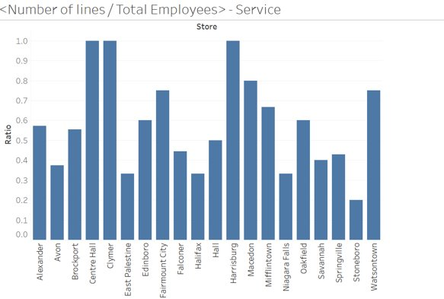

***Figure 15***

For Admin department, the issue is similar in each region. Thus, it may be related to the other operation and structure issues inside the department rather than impacted by the assigned tasks or size of stores.

**Average Answered call per Line**

The average answered call volumes varies in each department. In the Admin department, each regular phone line would need to answer 300 calls each month, which is less than the Parts and Service (550 and 450). The result is not surprising as the Parts department may receive the most phone calls; even the department with more employee and phone line, it still has the highest number of phones answered per line. Similarly, the Admin and Sales department has less total phone calls and average answered calls. However, for the Service department, the average call volume is high even when the volume is 6% less. This results from the low number of regular lines in this department.

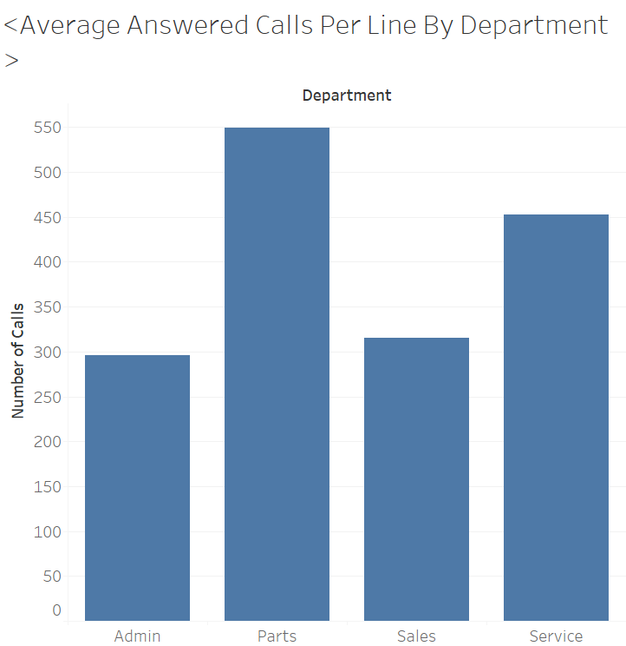

***Figure 16***

**Store Size and Peak Seasons’ Average Call Volume Comparation at Geographical Level**

|  |  |  |
| --- | --- | --- |
|  | Large Store | Small Store |
| Service | Brockport, Hall, Falconer, Watsontown | Edinboro, Fairmount City, Macedon, Savannah |
| Parts | Hall, Brockport, Avon | Fairmount City, Macedon, Savannah |
| Sales | Springville, Watsontown | Clymer, Edinboro |
| Admin | Avon, Falconer, Stoneboro | Niagara Falls |

* Above we list out regions whose average call volumes during peak seasons were way larger than others by departments and store sizes.
* Not all large stores imply to have a higher average call amount during peak season, the same concept applies to small stores. There’s no necessary relationship between these two elements.
* For Fairmount City, Macedon, and Savannah (small size stores), they tend to have a higher average call amount on Service and Parts department. This may suggest that average call volumes in these areas were high during peak seasons.
* For Niagara Fall, the reason of higher average call volumes may be inefficient call transfer or lack of employees on answering the call.
* While going through the plot in each region, we found that for the Sales department, the variation on average answer call is more stable. For Parts and Service, it’s more dependent on the region.

**Example on department - Niagara Falls**

|  |  |
| --- | --- |
| Item | Number |
| Call Volume | 34,289 |
| Missed Call | 28,923 |
| Missing Rate | 84.4% |

Niagara Falls is a small-sized store with relatively low answered rate comparing to other stores. During the peak season, almost all incoming calls rang overall all department. Mostly, calls were picked up by Parts department. However, there were no regular lines in Parts and Service departments, the admin department suffered high average calls per line. Thus, the reason for high missing rate may rise from inefficient call transfer or lack of employee on answering the call. The store may consider train staff to answer the overall questions.

## Solutions and Recommendations

1. **Call Center**

* During the peak season (April, May and June), LandPro Equipment can establish a call center for the calls regarding general questions. If possible, assign senior-level staff to instruct call center’s employees to answer specific questions for all the departments, which reduce the chance of redirecting the call to other departments/ regions meanwhile relieving the potential pressure for those branches.
* From the perspectives of branches, we believe this call center can help ease the pressure from the stores including Niagara Falls, Harrison, Macedon and East Palestine. The call center can be a seasonal operation that runs during the peak season to help avoid overwhelming call into specific stores.
* Furthermore, call center can also play a role as a terminal to monitor and redirect phone calls to other specific branches/ departments that have lower call volume and missing call rate to allocate calls to the right staff to answer the right question.

1. **Shifts rescheduling**

* From Weekday vs. Weekend Analysis, we disclosed issues for some locations during weekends. The operating time of these stores is from Monday to Saturday. However, we found there are still calls that were picked up on Sunday. Thus, we infer there are still employees answering these phone calls but since it is weekend, the work efficiency or available answering time varies from weekdays. To improve this high missing rate in Harrisburg, Avon, Hall, and Savannah, we suggest providing more available time slots answering phone calls or make a statement to customers that stores are closed on Sunday. If customers’ problems can be solved during open hours and they stop calling during weekends, this high missing call rate problem would be avoided.
* This point is created for several branches individually based on their unique performance:
  + Niagara Falls branch is highly recommended to increase shifts on Monday and Tuesday in April and Monday in May.
  + East Palestine branch is recommended to increase shifts on Monday in both April and May.
  + Macedon branch is recommended to increase shifts on Monday, Tuesday and Friday in June.
  + Harrisburg branch is highly recommended to increase shifts on Monday in May.
  + Oakfield branch is highly recommended to increase shifts on Friday in June.
* From the insights we acquired above, there is a tendency that the highest missing call rates appear on Monday and Friday. These two days are either at the beginning of the week or the closing day of the week. We believe something can be changed or emphasized to the workforce within these two days to improve the overall performance on the incoming calls.

1. **Staff Deployment - Department/ Region**

* Relocating staffs from low missing call rate departments/regions to the high missing call rate departments/regions. For instance, Falconer, Springville, Alexander and Oakfield were the cities in New York state with low missing call rates. Those stores can relocate their staffs to Macedon and Niagara Falls, which are also located in New York state but had high missing call rates. If one branch is the only one in the state, such as Ohio just had one branch in East Palestine, our team suggested to hire more staffs as there’s no other branches can support the store.
* Assign/Compensate the staff to work multiple close locations in the same state. For instance, stores in Halifax, Centre Hall, Watsontown in Pennsylvania can have staff moving all the way round with the stores in Harrisburg, which comparably had higher missing call rate.
* As we defined the big and small stores, big stores with more employees can relocate to small stores in the same state. For instance, the big store in Avon, NY can relocate staffs to small stores in Niagara Falls, NY or Savannah, NY.
* For Niagara Falls branch, since customers cannot reach out to the specific department, the issue can be fixed by improving system so that customers are able to reach out to a specific department or we can train the staff to answer overall questions. Given Admin department has the lowest volume of call and has relatively high missing call rate, so more employees can be assigned to answer phone call which is directed to Admin department. Given volumes and answered rate of cross call are both lower than targeted calls’, company can train more employees who can answer overall questions, places like East Palestine, Harrisburg, Macedon, Springville, Savannah.

1. **Training Staff on answering overall questions**

* For stores with more diversified calls, we suggest considering more training on people who can answer overall questions in each department. For instance, in the Niagara Falls store, almost all the calls to multiple departments and in the end mostly the Admin department will answer the call. Thus, we suggest training staff in the Admin department to answer the overall questions.
* The top 4 stores with the largest missing call volumes were all small size stores. Thus, we suggest considering providing training for staff in small size stores to answer overall questions. Meanwhile, Fairmount City, Macedon, and Savannah, which are small size stores, tend to have higher average call volumes in Service and Parts department. This may suggest that the burden on phone call volume in this area was high during peak season.
* The Sales department relies more on other departments to answer the call. Therefore, we recommend considering adding or training more employees or setting regular phone lines in the Sales department. In both ways, client could enable more employees to answer calls from its original department, like Admin and Service department.

***We would like to appreciate our client Land Pro Equipment for this Opportunity for our team to conduct this analysis project. We enjoyed and learned a lot from this journey!***

1. Based on the background of the client’s telephony upgrade process, the datasets are to be considered complete from February 2020 as it contains data from all operating branches.
2. Peak season represents months of April, May, June.
3. This approach was based on the second data frame we showed in the previous section.